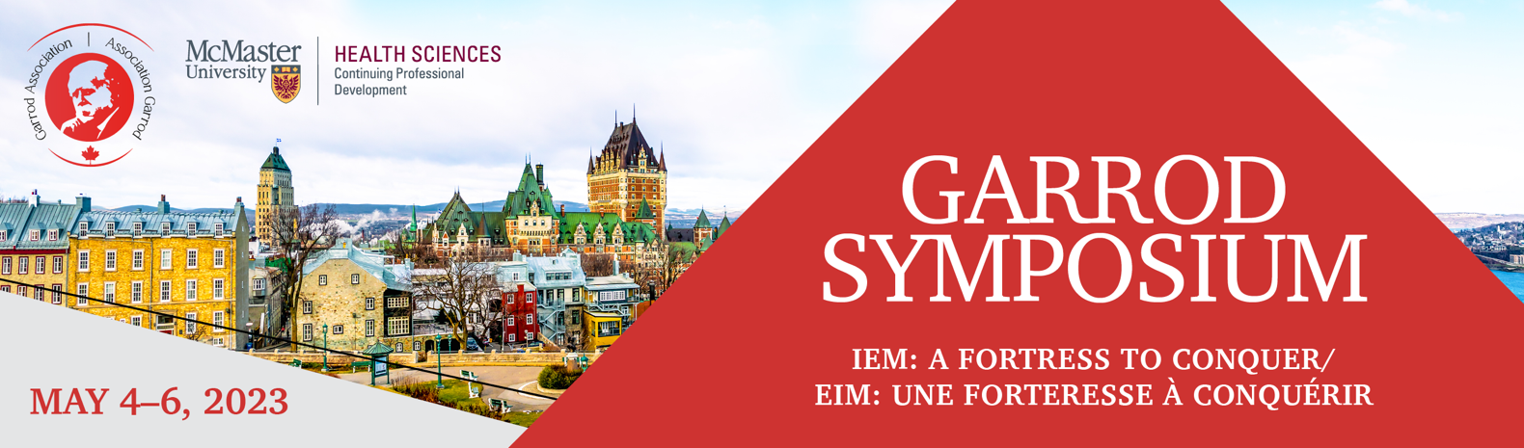
TRAVEL BURSARY GARROD SYMPOSIUM QUEBEC CITY 2023

Bursary Amounts: $500 - Province of Quebec, $1000 - Ontario and Maritimes $1500 - Rest of Canada
Eligible for travel bursaries: Trainees and Allied Health Professionals.

Please email the completed form to Carol Stewart castewa@mcmaster.ca
McMaster University, 1280 Main St W, DBHSC, Room 5004, Hamilton, ON, L8S 4K1, Canada
Information (sections are fillable)
Name |  |  |  | Phone |  |  |  |  | Email Address
Address
City |  |  |  |  | Province/State |  |  |  |  | Postal/ZIP Code
Profession/Institution
Reimbursement: Direct Transfer
Account Name |  |  |  |  |  |  | Account and or IBAN number
Bank Name |  |  |  |  |  |  | Bank Address
Sort Code/Routing Number/BSB Code |  |  |  |  |  |  | Bank Swift/BIC Code
Signature |  |  |  |  |  |  | Date

Please Note: If you do not wish to have direct deposit, we can mail you a cheque to the address above.

